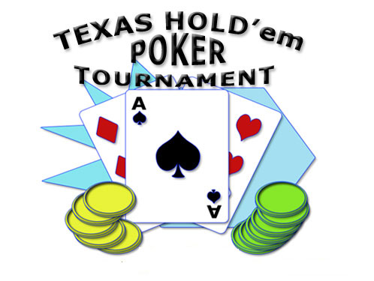CHANGE OF DATE
Regency Poker Club Texas Hold’Em Tournament
Thursday July 15th at 6:30 PM at the Clubhouse.
The Regency Poker Club is back! We will once again be holding our Texas Hold’Em Tournaments played with professional dealers and tables. No need to travel to Atlantic City or Parks Casino. Our tournaments are held right here at Regency. The club is open to all men and women who are Regency residents.
We are scheduling our first tournament on Thursday July 15th at 6:30 PM. There will be a $140 buy in. All the money collected, minus expenses for the dealers and tables, will be distributed as prizes.
If you are interested in joining our tournament, please complete the form and place it in my mailbox along with your check made out to Regency Poker Club for $140 by June 30th.
If you have any questions contact
Frank Gottlieb 10 Sahalee Drive
cell: 732-995-8109 home: 732-851-2135
email: frankgott1@aol.com

Regency Poker Club July 15th Texas Hold’em Tournament

Name:_____________________________________________________________

Address:____________________________________________________________

Phone:_____________________________________________________________

Email:______________________________________________________________

Disclaimer
By signing this document, I acknowledge that I have voluntarily chosen to participate in this activity. I assume all risk, and on behalf of myself, my heirs, beneficiaries, dependents, and personal representatives, release, hold harmless and indemnify FirstService Residential, Regency at Monroe Homeowners Association, Inc and the Board of Trustees, and each entity’s affiliates, subsidiaries, shareholders, members, directors, officers, employees, and agents from any responsibilities, liabilities, financial damages, or claims related to my participation in this activity.

Signature:_________________________________________________________

